**4-1.Buzzer**

**1.Preparation**

1.You should learn about the position of the buzzer in the body of hellobot；

3.You should learn about the micro:bit pins connected to the buzzer in the schematic.

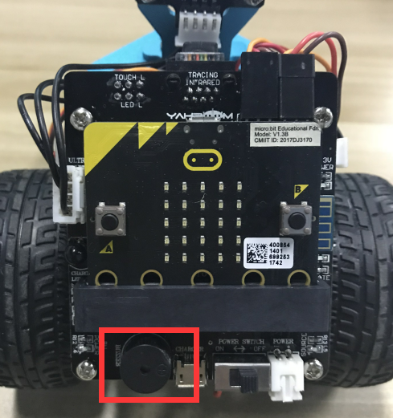

4-1-1 buzzer on arm of hellobot

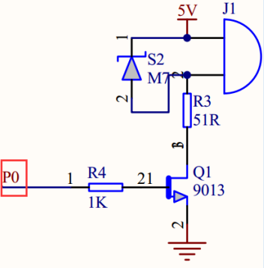

4-1-2 schematic

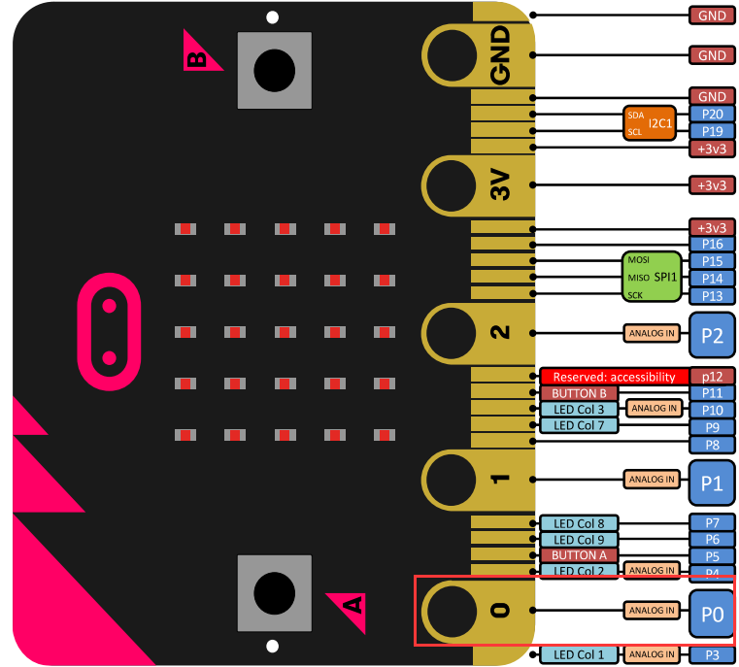

4-1-3 Pins of Micro:bit

From the schematic diagram in P4-1-3, you can see that the touch magic lights is connected to the P0 of the Micro:bit. You can use the blocks of music directly.

1. **Learning goals**

In this course, we will study how to make HelloBot robot sing “Happy Birthday”

**3.Programming**

3.1 Programming online

**1) You should use the USB cable to connect the micro:bit to the computer, at this point, the computer will have a micro:bit U disk. You need to open it, click micro:bit website, then entered the micro:bit website** or you can enter the URL directly in your browser: http://microbit.org/

2) After entering the programming interface, you need to click Add package and copy the HelloBot package URL: https://github.com/lzty634158/HelloBot to the input field, click to confirm the add package. Then you can use the blocks of the HelloBot package.

3.2 Programming offline

1) You can double-click to use it. As shown in the following figure.

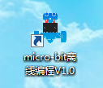

2) After entering the programming interface, you need to click Add package and copy the HelloBot package URL: https://github.com/lzty634158/HelloBot to the input field, click to confirm the add package. Then you can use the blocks of the HelloBot package.

Note: The package only needs to be added once. If you have added packages in the previous lessons, this course does not need to be added repeatedly.

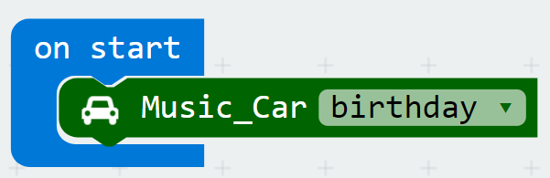

4-1-4 total program

The locations of blocks in the total program are shown in the following figure.

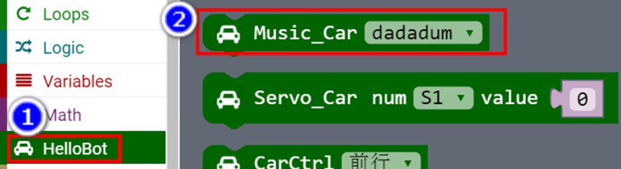

4-1-5

4.Download programming

You need to make sure that the micro:bit development board is connected to the computer. Then you should click on the download in the lower left corner as shown in P 4-1-6 to download the program to micro:bit.

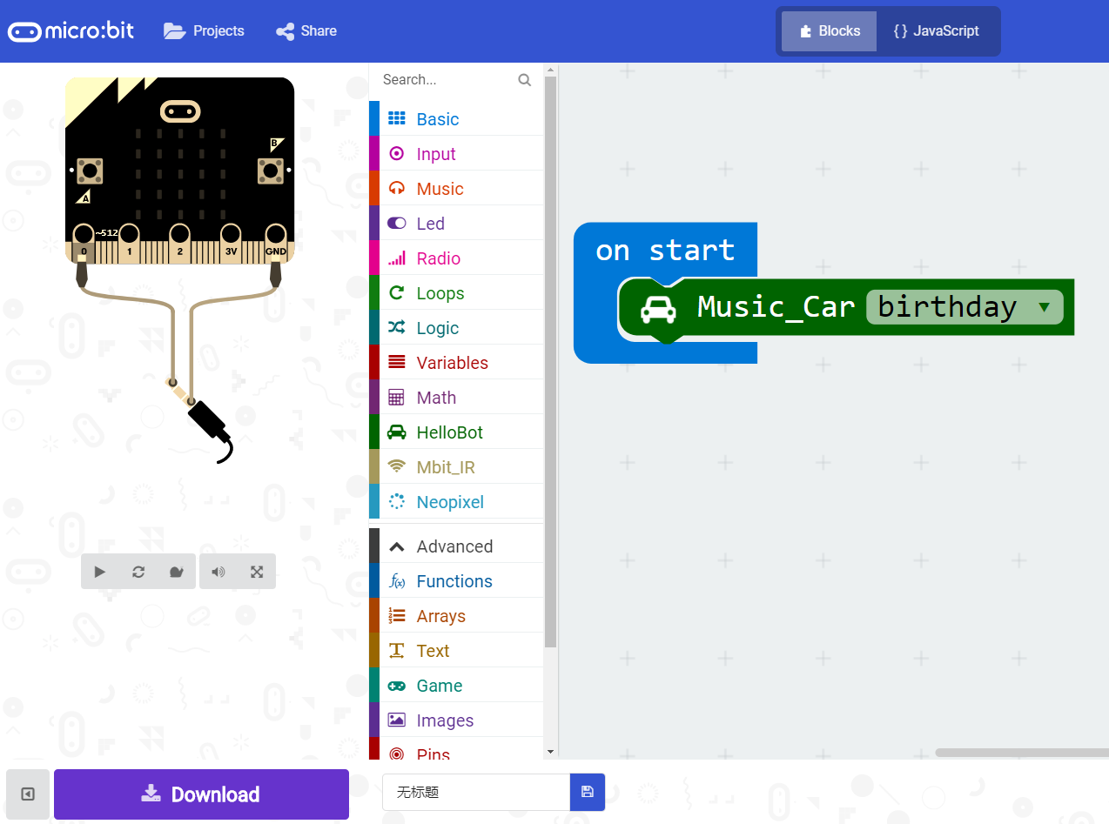

4-1-6

5.Phenomenon

After the code is uploaded. HelloBot robot will sing “Happy Birthday”.